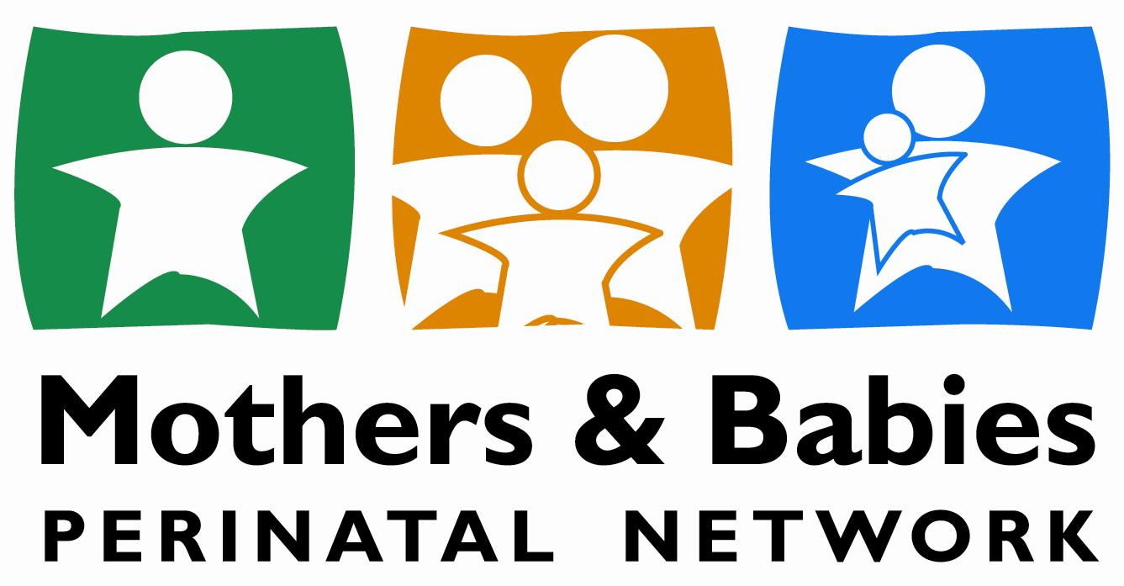

Of South Central New York, Inc.

JOB TITLE: JOB TITLE: **PAL COORDINATOR**

PROJECT: **PAL FAMILY RESOURCE CENTER**

REPORTS TO: **FSS PROGRAM MANAGER**

Under the direction of the Family Support Services Program Manager, the PAL Coordinator will ensure a strength based, welcoming, supportive program for participants and young children. PAL Staff will work in partnership with community agencies to provide services, information and resources for families. The PAL Coordinator will work closely with the Family Support Services Director to identify strategies to reach and work with high risk families in the community and/or involved with the Foster Care System.

**Responsibilities will include, but may not be limited to:**

* Planning activities and programs offered through the PAL Center.
* Implement developmentally appropriate activities for parents and children.
* Provide One-on-One Mentoring that includes support, goal setting, life skills, and parent education.
* Facilitate parent education programs with pre and post evaluations.
* Input daily progress notes, contact logs, and intakes into AWARDS database.
* Work together with caseworkers to plan and implement strategies and goals for clients utilizing supervised visitation.
* Provide monthly reports and grant required paperwork to the FSS Director at the beginning of each month.
* Daily cleaning and maintenance of the Center.
* Prepare materials for activities and meals.
* Plan and implement special events.
* Engage all families in Center programs. Provide a warm and non-judgmental atmosphere.
* Role model effective positive parent/child communications and interactions.
* Facilitate educational, support programs, and workshops scheduled at the PAL Center.
* Oversee Parent Partners and supervise volunteers/ student interns. Assist FSS Director with new staff orientation and training.
* Attend and participate in staff meetings, in-services, and professional trainings.

**Areas of Expertise:**

* Family support principles: welcoming, encouraging, engaging, nonjudgmental.
* Strong oral communication and interpersonal skills.
* Knowledge of early childhood development, behavior management, ACE’s, childhood trauma, parenting education, foster care.
* Knowledge of the community and human service programs.
* Working with “high risk” populations: [parents/children living at or near poverty level, those with cognitive limitations, low literacy, mental health issues, teen parents, or engaged in the foster care system].

**Minimum Qualifications:**

* Minimum Associates degree in social work, early childhood, health/ human service field
* Minimum 3 yrs. experience working with parents and children
* Able to work 2-3 evenings/week and occasional weekend special event

THE POSITION OF PAL PARENT PARTNER COORDINATOR IS A FULL-TIME, NON-EXEMPT POSITION AND IS THEREFORE SUBJECT TO THE PROVISIONS OF THE FAIR LABOR STANDARDS ACT.